Apache Pig
Pig is a high-level platform for processing and analyzing large data sets. It provides a scripting language called Pig Latin that is used to express data transformations.
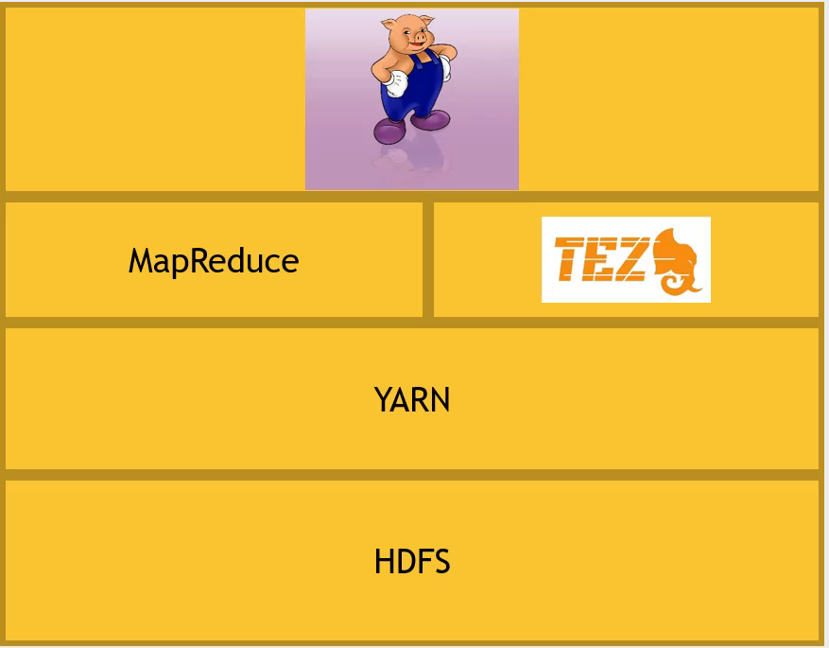
This image represents the architecture stack of a Hadoop-based data processing system, highlighting the role of Apache Pig and the underlying components it relies on. Here’s an explanation of each layer and their relationships:
Layered Architecture Overview
- Pig:
  - At the top of the stack, we see an image representing Apache Pig. Pig is a high-level platform for processing and analyzing large data sets. It provides a scripting language called Pig Latin that is used to express data transformations.
- Execution Engines (MapReduce and Tez):
  - MapReduce: One of the execution engines that Pig can use to process data. MapReduce is a programming model and processing engine for distributed computing. It breaks down jobs into a map phase and a reduce phase.
  - Tez: An alternative execution engine that can be used instead of MapReduce. Tez is designed to be more efficient and flexible, allowing for complex directed acyclic graphs (DAGs) of tasks for data processing. This can lead to better performance compared to the traditional MapReduce model.
- YARN (Yet Another Resource Negotiator):
  - YARN is the resource management layer of Hadoop. It is responsible for managing resources in a Hadoop cluster and scheduling jobs. Both MapReduce and Tez run as applications on YARN, using its capabilities to allocate resources and execute tasks.
- HDFS (Hadoop Distributed File System):
  - HDFS is the storage layer of Hadoop. It provides distributed storage that is highly fault-tolerant and designed to run on commodity hardware. Data processed by Pig (via MapReduce or Tez) is typically stored in HDFS.
How They Work Together
- Apache Pig provides an easy-to-use scripting language to define data transformations.
- Pig Scripts are compiled into execution plans that run on execution engines like MapReduce or Tez.
- The execution engines (MapReduce/Tez) perform the actual data processing tasks. These tasks are scheduled and managed by YARN, which ensures that resources are allocated efficiently across the cluster.
- The data being processed is stored in HDFS, which ensures reliability and scalability by distributing the data across multiple nodes in the cluster.
Key Points:
- Pig abstracts the complexity of writing MapReduce jobs by allowing users to write high-level scripts.
- MapReduce and Tez are the engines that perform the actual data processing defined by Pig scripts.
- YARN manages the cluster resources, ensuring that processing tasks get the necessary resources to execute.
- HDFS provides the underlying storage for the data being processed.
This layered architecture shows how different components of the Hadoop ecosystem interact to process and analyze large datasets efficiently. By using Apache Pig with either MapReduce or Tez, you can leverage the power of distributed computing with simpler scripting and better performance optimizations.

Apache Pig & MapReduce
Apache Pig uses MapReduce behind the scenes to process data. Here's a detailed explanation:
Overview of Apache Pig
Apache Pig is a high-level platform for creating programs that run on Apache Hadoop. The language for this platform is called Pig Latin, and it abstracts the complexity of writing MapReduce programs. Pig is used for processing and analyzing large data sets.
How Pig Works
- Pig Latin Script: Users write their data analysis tasks in a high-level language called Pig Latin.
- Compilation: The Pig Latin script is then compiled into a sequence of MapReduce jobs.
- Execution: These MapReduce jobs are executed on the Hadoop cluster.
MapReduce in Apache Pig
- Abstraction: Pig provides an abstraction over the traditional MapReduce programming model. This allows users to write less code and makes the data processing tasks easier to manage and understand.
- Translation: When you write a Pig Latin script, Pig translates it into a series of MapReduce jobs under the hood. Each operation in the script corresponds to a specific MapReduce job or series of jobs.
- Optimization: Pig also includes a number of optimizations that it applies to the MapReduce jobs it generates. This can include combining jobs, reordering operations, and other performance enhancements.
Example Workflow
- Pig Latin Script:
pig
Copy code
-- Load data
data = LOAD 'input_data.txt' USING PigStorage(',') AS (field1:int, field2:chararray, field3:float);

-- Filter data
filtered_data = FILTER data BY field1 > 10;

-- Group data
grouped_data = GROUP filtered_data BY field2;

-- Aggregate data
result = FOREACH grouped_data GENERATE group, COUNT(filtered_data), AVG(filtered_data.field3);

-- Store result
STORE result INTO 'output_data.txt' USING PigStorage(',');
- Compilation to MapReduce:
  - Load Data: The LOAD function is translated into a MapReduce job that reads the input data.
  - Filter Data: The FILTER operation is translated into a MapReduce job that filters the records based on the condition specified.
  - Group Data: The GROUP operation translates into a MapReduce job that groups the data by a specified field.
  - Aggregate Data: The FOREACH operation generates a MapReduce job that performs the aggregation functions like COUNT and AVG.
  - Store Result: The STORE function translates into a MapReduce job that writes the output data to a specified location.
Advantages of Using Pig
- Simplified Data Processing: Pig Latin provides a simpler way to write data processing tasks without dealing directly with the complexities of MapReduce.
- Productivity: Developers can write and maintain less code compared to writing raw MapReduce jobs.
- Reusability: Pig Latin scripts can be easily reused and shared among different teams or projects.
- Extensibility: Users can write their own functions (UDFs) to perform custom processing tasks.
Conclusion
Apache Pig indeed uses MapReduce behind the scenes. It provides an abstraction layer that simplifies the development process, allowing users to write high-level scripts in Pig Latin, which are then compiled into efficient MapReduce jobs that run on a Hadoop cluster. This abstraction helps improve productivity, maintainability, and reusability in large-scale data processing tasks.

